Buckeye United Fly Fishers Annual
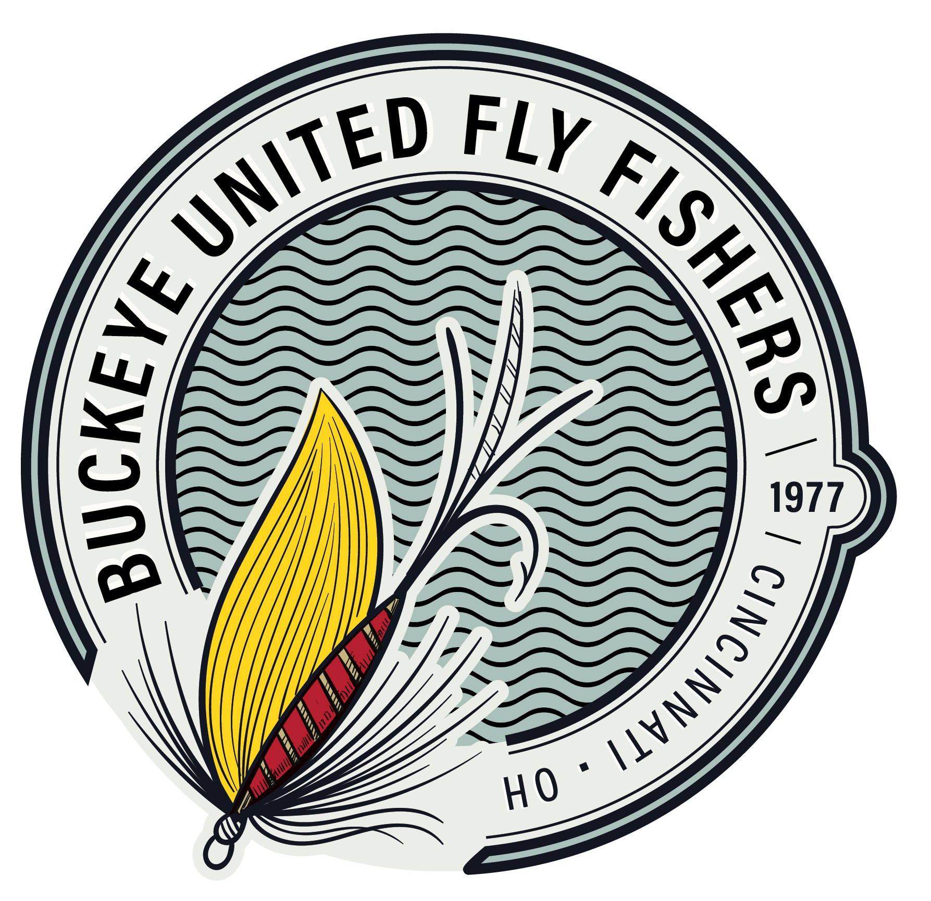
Banquet, Raffles, and Auction
Wednesday, March 11, 2026

At The Oasis
902 Loveland Miamiville Rd, Loveland, OH 45140

Buckeye United Fly Fishers will host our Annual “BUFF Banquet” on Wednesday, March 11, 2026. The purpose of this event is to raise funds to support our educational, charitable, and conservation activities. Some of those activities include:

- BUFF Volunteers teach children how to fish on fishing days on local ponds.
- Casting for Recovery Retreat every year that provides fly-fishing retreats tailored for women who have or have had breast cancer. CFR provides retreats at no cost.
- Reel Recovery helps men in the cancer recovery process by introducing them to the healing powers of the sport of fly-fishing. It provides them with new skills to bring joy, enthusiasm and renewed hope as they confront the challenges of their cancer survivorship.
- BUFF is committed to the conservation and preservation of our environment. In recent years, BUFF has made donations to the Little Miami Conservancy, Rivers Unlimited, Three Rivers Conservation Trust, Izaak Walton League, Anglers of the Au Sable, Mad River Chapter of Trout Unlimited, Ohio River Foundation, and the Mill Creek Alliance.
- BUFF Volunteers help with Butler and Clermont County River Clean-up Days.

Along with a buffet dinner, the event features many silent auctions as well as raffle items. While the silent auctions are typically guided trips, the raffles also include non-fishing related items for men and women.

Winners of the 2025 Fly Fisher of the Year, Board of Directors Award, President’s Awards, and Education, Fly Tying and Conversation Awards will also be announced and recoginized.

Name:______________________________
Email: ______________________________ No. Total
Banquet Dinner Reservations $55.00 ________ _________
Raffle Tickets $5.00 ________ _________
Grand Raffle Tickets $10.00 ________ _________ Total Enclosed _________

Buffet Dinner will include two entrees, Grilled Salmon and Caribbean Sliced Pork Loin, Salad, Rolls, two Sides, and Dessert. Appitizers will be available before dinner.

Payment Type: | Cash | Check | Or use PayPal online or Square at the Monthly Meetings

Please make checks payable to “Buckeye United Fly Fishers, Inc.” Mail to Cari Vota, Banquet Reservations, 883 Windrow Lane, Milford, OH 45150
This form must accompany mail-in reservations. Form Deadline 3-03-26

